Technical Architecture:

Project Design Phase-II Technology Stack (Architecture & Stack)

|  |  |
| --- | --- |
| Date | 09 November 2022 |
| Team ID | PNT2022TMID03082 |
| Project Name | AI-based localization and classification of skin disease with erythema |
| Maximum Marks | 4 Marks |

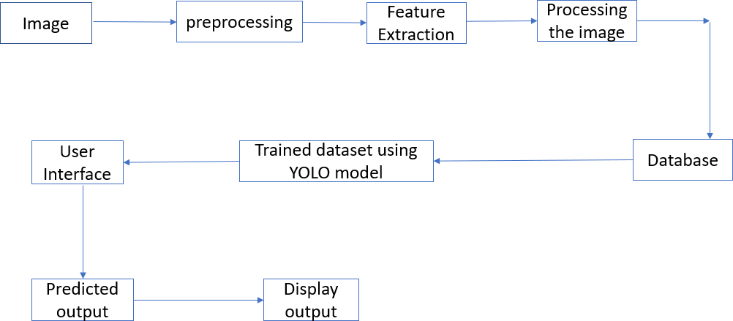

Table 1:Components and Technologies:

|  |  |  |  |
| --- | --- | --- | --- |
| **S.No** | **Component** | **Description** | **Technology** |
| 1. | User Interface | The point of human computer interaction and communication in a device.This can include display screens,keyboards,a mouse and the appearance of a desktop.It is also the way through which a user interacts with  the application or a website. | In Vision studio,Axure,Adobe XD,Web flow. |
| 2. | Application Logic-1 | Logic for a process in the application | Python |
| 3. | Application Logic-2 | Logic for a process in the application | IBM Watson Assistant |
| 4. | Cloud Database | Database Service on Cloud | IBM Cloudant |
| 5. | Machine Learning Model | Purpose of Machine Learning Model | Object Recognition Model |
| 6. | Infrastructure (Server / Cloud) | Application Deployment on Cloud Server Configuration : | Kubernetes |

Table 2:Application Characteristics:

|  |  |  |  |
| --- | --- | --- | --- |
| 1. | Open-Source Frameworks | A software for which the original source code is made freely available and may be redistributed and modified according to the requirement of user. | Esri Geographical Server and ArcGIS Editor for open street map. |
| 2. | Security Implementations | Security Technology are concepts,policies and components designed to minimize risk,identity vulnerabilities,and inform how and when to  respond to potential incidents | Artifical Intelligence and Machine Learning |
| 3. | Scalable Architecture | Prioritizing it from the start leads to lower maintenance costs,better user experience,and higher agility. | Cloudinary(like a lot of technology companies looking to conquer scalability issues) is using a degree of  Artifical Intelligence. |